Watch the film : Mrs Smith goes to washington court

To lose one’s temper = perdre sa patience

Politics = politsique

2 party system: 🡪 US: Winner take all system (US)

US: Democratic Party/Republican Party

Symbols: (Donkey) (Elephant)

GB: Labour Party / Conservative Party

Federal: States 50 🡪 elect the President separately

Indirect election: Voters elect (1st Tuesday following the 1st Monday of November) Electors, electors elect the President and the Vice-President.

Congress

House of Representatives

(438 representatives)

The Senate

100 Senators

(50*2)

Big states : California/Texas/New York/Florida/Illinois …

Small States : Vermont/Delaware/Rhode Island …

538 Electors

Magic Number : 270 (269+1 (538/2)) will be showed somewhere on the screen on an American TV.

If a Candidat reaches 270 electors he becomes president.

Electors:

California: 55

Texas: 38

New York: 29

How does it Work:

|  |  |  |  |
| --- | --- | --- | --- |
|  | Trump | Bidon | Winner (269+1) |
| California 55(1000 people) | 20% | 80% | Biden 55 people, Trump 0 people |
| Texas 38 (600 people) | 100% | 0% | Trump 38 people, Biden 0 people |
| New York 29 (500 people) | 50.0001% | 49.999% | Trump 29 people, Biden 0 people |

Biden 55

Trump 67

Voters per city:

Voters

Red

States

Color

Blue

Projection of the possible results of the next election.

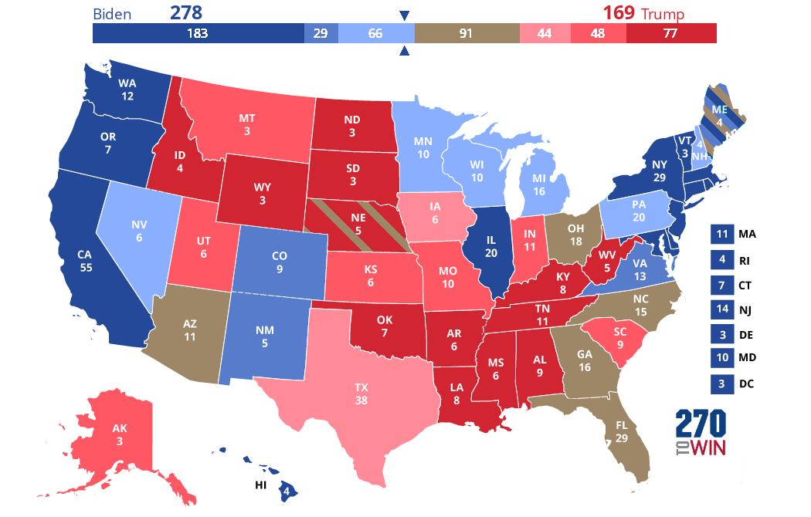

<https://www.270towin.com/maps/KPzlO.png>

Research: Inaugural Ball

Oath of office: Barack Obama Oath of Office/Sworn In -President Obama:

<https://www.youtube.com/watch?v=m1Yff-_9MZs>

Ronald reagan landslide map electoral college

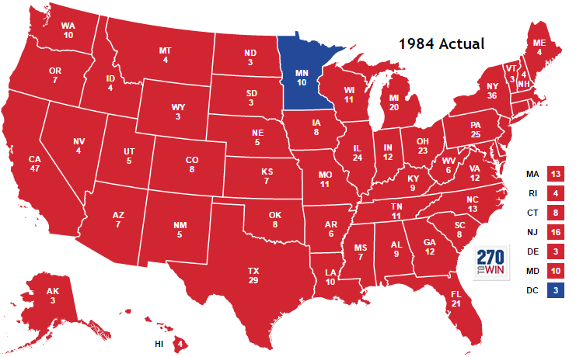

<https://www.270towin.com/historical_maps/1984_large.png>

Mme Garelik did her PHD in American history (more specifically on the voting history), she was a history teacher before becoming an English teacher.

Regarder: Quotidient livres et vous : Public Sénat 9 février 2018, Public Sénat TMC

(Les lectures “coups de Coeur” de Nicolas Sarkozy